Proactive Congestion Prediction in 5G RAN
A Hybrid Spatio-Temporal Model Trained on Simulation and Evaluated on Real O-RAN Telemetry
Project proposal for review
Guide: Dr. Radhika Joshi
Department of Electronics and Telecommunication Engineering, COEP Technological University, Pune
10 September 2026

1. Title
Proactive Congestion Prediction in 5G RAN: A Hybrid Spatio-Temporal Model Trained on Simulation and Tested on TRACTOR data

2. Scope
Short-horizon forecasting, up to one second ahead, of radio-access congestion at per-UE and per-cell granularity, across a multi-cell urban cluster with mobility, handover and three service classes (eMBB, URLLC, mMTC). Prediction uses standard key performance measurements only, with no packet inspection and no access to user payload. Evaluation covers both simulated and real O-RAN telemetry, and includes measured inference latency assessed against near-real-time RIC timing bounds.

3. Aim
To develop and evaluate a slice-aware congestion-prediction model that is trained entirely on simulated 5G RAN telemetry, generalises to real O-RAN key performance measurements, and is computationally light enough to run as a near-real-time RIC xApp.

4. Objectives
1. Architect a reproducible simulation-to-dataset pipeline that emits O-RAN-aligned key performance measurements at 250 ms granularity, with a congestion label derived from resource-allocation and buffer signals rather than from end-to-end latency, thereby removing the feature-target leakage identified in earlier work.
2. Analyse five forecasting approaches, namely moving average, ARIMA, LSTM, temporal convolutional network and GraphSAGE graph neural network, under a single evaluation protocol with statistical baselines, multiple random seeds and confidence intervals.
3. Synthesise a hybrid spatio-temporal model in which cell-level graph aggregation supplies neighbourhood context to a per-UE temporal encoder, and determine by ablation whether graph message passing outperforms simple hand-computed cell aggregates.
4. Assess simulation-to-reality transfer by evaluating simulation-trained models on a real O-RAN key performance measurement dataset, quantifying both the zero-shot transfer gap and the accuracy cost of restricting the feature set to quantities observable in real telemetry.

5. Methodology
The work proceeds in five stages. Two data paths, one simulated and one real, converge on a single shared feature schema before any model is trained.

5.1 Stage 1 — Pipeline reconstruction
The existing OMNeT++ / Simu5G pipeline is repaired. Vector recording is corrected so that MAC buffer occupancy and served resource-block counts populate; throughput is recomputed as a per-bin byte delta rather than an aggregated rate signal; the redundant RLC-delay feature is removed; fixed-rate downlink traffic is replaced with elastic traffic capable of responding to load; and repeated runs are enabled to permit confidence intervals.

5.2 Stage 2 — Scenario design with service classes
UEs are partitioned into three service classes mirroring the structure of the real dataset: eMBB (adaptive video and bulk transfer, stationary and pedestrian), URLLC (small bidirectional conversational flows, pedestrian) and mMTC (sparse uplink background traffic, stationary and vehicular). Mobility class, device transmit power and session churn vary by group. Resource isolation between classes is implemented by splitting component carriers where feasible; where it is not, the arrangement is reported as service-class differentiation rather than as network slicing.

5.3 Stage 3 — Shared schema and label definition
Both data paths are reduced to eight common key performance measurements, resampled to 250 ms bins, expressed as per-UE normalised ratios rather than absolute magnitudes, and scaled with a scaler fitted independently on each source's training partition. The congestion label is defined per service class as the conjunction of two conditions drawn from different points in the causal chain: a resource-grant deficit, and rising buffer occupancy.
A secondary continuous target, estimated queueing delay, is derived as buffer occupancy divided by service rate. Both of its components are present in the real dataset, whereas end-to-end latency is not. The proxy is validated in simulation against ground-truth measured latency, and the resulting correlation is reported as justification for its use.

5.4 Stage 4 — Modelling
All five baselines are retrained on the corrected data and the revised label. The hybrid model computes a per-cell graph embedding over UEs sharing a serving cell, with service class carried as a node feature and the graph deliberately left un-partitioned so that cross-class contention remains visible, then concatenates that embedding with per-UE features before a temporal encoder. Models are trained directly against a classification objective and probability-calibrated; no operating threshold is hand-selected.

5.5 Stage 5 — Evaluation
Four experiments establish the transfer picture, supported by trivial baselines that establish the performance floor.
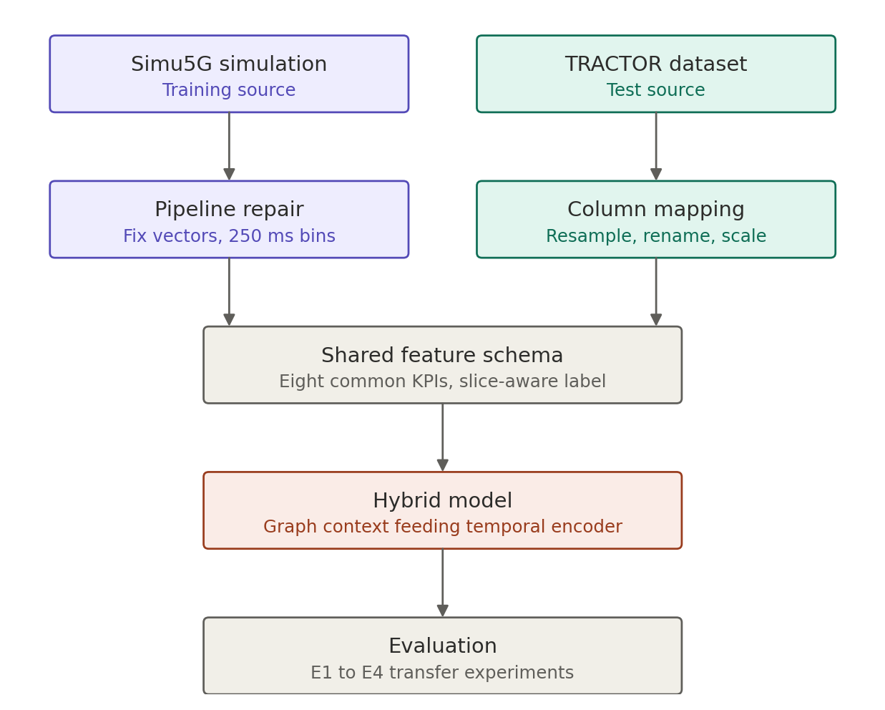
Figure 1 — Methodology block diagram. Two data sources converge on one shared feature schema.

6. Experimentation

6.1 Key performance measurements used
Eight quantities present in both the simulated and the real dataset: downlink buffer bytes, uplink buffer bytes, granted physical resource blocks, downlink channel quality indicator, uplink signal-to-interference-and-noise ratio, downlink bitrate, uplink bitrate, and uplink packet error percentage. Requested physical resource blocks are added as a ninth if the simulator exposes them, which is yet to be confirmed.
A second, richer feature set, adding measured latency, downlink SINR, downlink HARQ statistics and graph-derived neighbourhood features, is used for simulation-only experiments to establish an upper bound.

6.2 Quality of service quantities reported
End-to-end latency and its ninety-fifth percentile, throughput, packet loss ratio and HARQ retransmission load, reported per service class. These characterise the scenarios and justify the label definition, but are not available as model inputs in the transferable configuration.

6.3 Datasets
Simulated. OMNeT++ 6.4.0 with Simu5G 1.4.3 and INET 4.6.0, on the UrbanCongestionCluster topology: one macro and three micro gNodeBs, four background interference cells, fifty UEs over a 1000 by 1000 m area, with dynamic cell association and handover enabled. Two congestion scenarios, burst and gradual ramp, ten seeds each.
Real. The TRACTOR open O-RAN dataset. Real smartphone traffic, captured across video streaming, browsing, file transfer, video calling and background activity, is replayed through a full-stack srsRAN-based O-RAN system on the Colosseum radio-frequency emulator, with key performance measurements retrieved from the gNodeB every 250 ms over the E2 interface. Seventeen key performance measurements are released. This is a real protocol stack carrying real user traffic over an emulated radio channel, not a live commercial network, and is described as such throughout. The dataset licence requires citation of the originating paper.

6.4 Experiments
ID | Train | Test | Purpose
E1 | Simulation | Simulation | Sanity check; establishes in-distribution performance
E2 | Simulation | Real, zero-shot | Headline result: unassisted simulation-to-reality transfer
E3 | Simulation, fine-tuned on a small real slice | Held-out real | Determines how much real data is actually required
E4 | Real | Real | Upper bound; E4 minus E2 is the measured sim-to-real gap

6.5 Metrics
- Precision-recall area under curve as the primary classification metric, since the positive class is a minority, supported by F1, precision and recall.
- Calibration assessed by reliability curve and Brier score.
- Advance-warning time distribution across all UEs and per service class, not for a single representative UE.
- Regression quality for estimated queueing delay.
- Deployment feasibility as parameter count and measured inference latency in milliseconds.

6.6 Baselines establishing the floor
Moving average; ARIMA; and a persistence baseline that predicts the future label equals the present label. If the hybrid model does not clearly exceed all three, that finding is reported plainly.

7. Deployment context
The model is designed to operate as an xApp on the near-real-time RIC, which hosts applications on control loops between 10 ms and 1 s. Model training and lifecycle management reside in the Non-RT RIC and SMO, communicating with the near-real-time RIC over A1, while measurements arrive from the E2 nodes over the E2 interface using the KPM service model.
Feature selection in this work is constrained to quantities obtainable from standard KPM reporting, so that the model is deployable in this configuration without access to node-internal state or handset-side instrumentation. Deployment and closed-loop evaluation are not performed in this work and are left to future work.
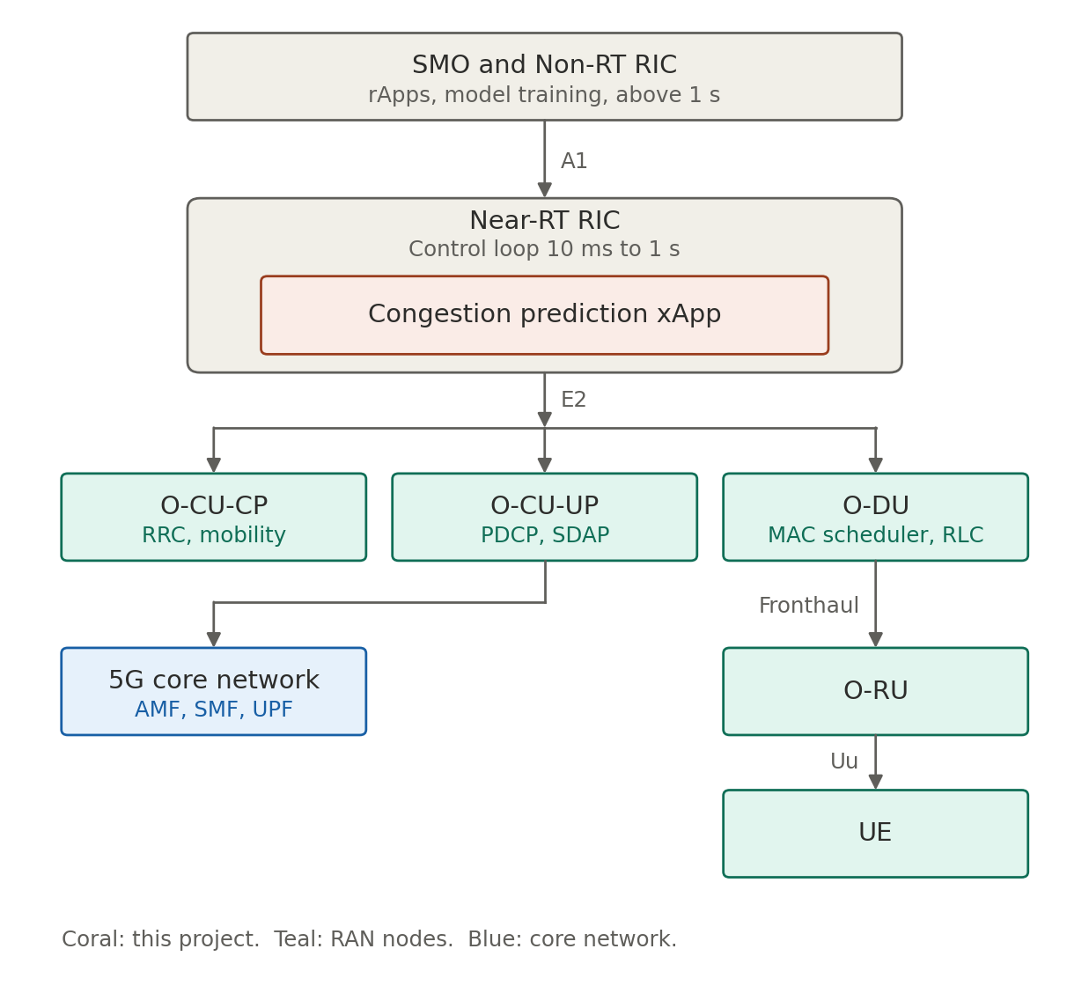
Figure 2 — Target deployment architecture. The proposed model is designed to run as an xApp on the near-real-time RIC. This placement is a design target; deployment is not performed in this work.
Origin of each input quantity in a real deployment:
Quantity | Producing node | Notes
Buffer bytes, downlink and uplink | O-DU | MAC and RLC buffer state
Requested and granted PRBs, MCS | O-DU | Scheduler allocation records
Downlink CQI, uplink SINR | O-DU | Derived from UE measurement reporting
Downlink and uplink bitrate | O-CU-UP | PDCP-level volume and throughput
Serving cell, handover events, slice identity | O-CU-CP | Context used to construct the graph edges
End-to-end latency | UE to UPF path | Not used; replaced by the queueing-delay proxy

8. References
- G. Nardini, G. Stea, A. Virdis and D. Sabella, “Simu5G – An OMNeT++ Library for End-to-End Performance Evaluation of 5G Networks,” IEEE Access, vol. 8, pp. 181176–181191, 2020.
- J. Groen, M. Belgiovine, U. Utku, B. Kim and K. R. Chowdhury, “TRACTOR: Traffic Analysis and Classification Tool for Open RAN,” IEEE International Conference on Communications (ICC), June 2024.
- A. Lacava et al., “ns-O-RAN: Simulating O-RAN 5G Systems in ns-3,” Proceedings of the 2023 Workshop on ns-3.
- M. Polese, L. Bonati, S. D’Oro, S. Basagni and T. Melodia, “ColoRAN: Design and Testing of Open RAN Intelligence on Large-scale Experimental Platforms,” arXiv:2112.09559.
- “OpenRAN Gym: AI/ML Development, Data Collection, and Testing for O-RAN on PAWR Platforms,” arXiv:2207.12362. Author list to be confirmed.
- “Twinning Commercial Network Traces on Experimental Open RAN Platforms,” arXiv:2409.16217. Author list to be confirmed.
- “How to Bridge the Sim-to-Real Gap in Digital Twin-Aided Telecommunication Networks,” arXiv:2507.07067. Author list to be confirmed.
- “On the Effects of Modeling on the Sim-to-Real Transfer Gap in Twinning the POWDER Platform,” arXiv:2408.14465. Author list to be confirmed.
- D. Raca et al., “Beyond throughput, the next generation: a 5G dataset with channel and context metrics.” Venue to be confirmed.
- B. M. Xavier et al., “Performance measurement dataset for open RAN with user mobility and security threats,” Computer Networks, 2024.
- O-RAN Alliance, E2 Service Model — Key Performance Measurement (O-RAN.WG3.E2SM-KPM), and O-RAN Architecture Description.
- ITU-T Recommendation Y.3172, Architectural framework for machine learning in future networks including IMT-2020.

9. Motivation and inspiration

9.1 Why this problem
Radio access networks today react. A scheduler observes that a queue has filled, or that latency has crossed a threshold, and responds, by which point the user has already experienced the stall. The information needed to anticipate that event was present in the network a second earlier, in buffer occupancy and in the pattern of resource grants. It simply went unused.
The reason it went unused was structural rather than technical. Until recently there was no standard way to stream fine-grained per-user measurements out of a base station, and no place to run third-party logic on them. A one-second warning was of no value because nothing could receive it.

9.2 What changed
O-RAN changed it. The architecture disaggregates the base station and exposes standardised interfaces, and the near-real-time RIC provides a hosting environment for applications operating on control loops between ten milliseconds and one second. Per-user performance measurements now flow out over a standardised service model, and an application can act on them within the same loop. A one-second forecast finally has somewhere to go.

9.3 The gap this project addresses
Congestion can already be forecast roughly a second ahead in simulation, including by our own earlier work. The question that determines whether any of it matters is different: does a model trained on a simulator survive contact with real telemetry?
Almost all published work in this area trains and tests on data from the same source, which measures interpolation rather than generalisation. This project deliberately tests across that boundary and reports the result honestly, including if the result is unfavourable. A measured negative transfer number is more useful to the field than another high score on synthetic data.

9.4 Future applications
- Closing the control loop, so that a predicted congestion event triggers a scheduling or mobility action rather than only an alarm.
- Energy saving, by predicting periods in which a cell may be powered down without service impact.
- Per-slice service-level protection, in which URLLC traffic is shielded from eMBB contention before degradation occurs rather than after.
- Intent-driven operation of 6G networks, in which an operator specifies a desired outcome and the network's own predictive models determine the configuration required to reach it.

